CineMax – Movie Recommendation Engine
Personalized Movie Discovery Using Data Structures and Algorithms
Project Report submitted for the partial fulfilment of grade for the course

Data Structures and Algorithms -3 (25CS2103E)
in

A.Y. 2026-2027

Submitted by
B. Srivalli (2520090220)
M. Shanmukhi (2520090076)

Team Number: 7
Section: 12

Under the guidance of

Ms. Chandusha
Assistant Professor, Department of Computer Science and Information Technology


Hyderabad-500090, Telangana, India.

K L (Deemed to be) University
DEPARTMENT OF COMPUTER SCIENCE ENGINEERING / COMPUTER SCIENCE AND INFORMATION TECHNOLOGY/ARTIFICIAL INTELLIGENCE & DATA SCIENCE



DECLARATION

The project report entitled “CineMax – Movie Recommendation Engine” is a record of bona fide work carried out by B. Srivalli (2520090220) and M. Shanmukhi (2520090076), submitted in partial fulfilment of the requirements for the course Data Structures and Algorithms – 3 (25CS2103E) at K L (Deemed to be) University. The work describes the design and implementation of a movie discovery interface that ranks titles using genre matching, rating, and a recency factor.

B. Srivalli – 2520090220
M. Shanmukhi – 2520090076

K L (Deemed to be) University
DEPARTMENT OF COMPUTER SCIENCE ENGINEERING / COMPUTER SCIENCE AND INFORMATION TECHNOLOGY
CERTIFICATE

This is to certify that the project report entitled “CineMax – Movie Recommendation Engine” is a bona fide work done and submitted by B. Srivalli (2520090220) and M. Shanmukhi (2520090076) in partial fulfilment of the requirements for the course Data Structures and Algorithms – 3 (25CS2103E), K L (Deemed to be) University, during the academic year 2026–2027.

Signature of the Supervisor

Signature of the HOD Signature of the External Examiner

ACKNOWLEDGEMENT

The success in this project would not have been possible but for the timely help and guidance rendered by many people. Our wish to express my sincere thanks to all those who has assisted us in one way or the other for the completion of my project.

Our greatest appreciation to our guide, Ms. Chandusha, Assistant Professor, Department of Computer Science and Information Technology, whose tremendous support, encouragement, and guidance have been invaluable throughout this project. We express our sincere gratitude for her guidance and assistance in successfully completing this project.

We express our gratitude to Dr. P.Venkateshwar Rao (CSE)/Dr. Khaja Shareef (CSIT)/ Dr. Sreenath Itikela (AI&DS), Head of the Department for Computer Science Engineering/ Department for Computer Science and Information Technology/Department of Artificial Intelligence and Data Science for providing us with adequate facilities, ways and means by which we are able to complete this project-based Lab.

We thank all the members of teaching and non-teaching staff members, and also who have assisted me directly or indirectly for successful completion of this project. Finally, I sincerely thank my parents, friends and classmates for their kind help and cooperation during my work.

B. Srivalli – 2520090220
M. Shanmukhi – 2520090076

TABLE OF CONTENTS

S.No. | Contents | Page no.
1. | Abstract | 6
2. | Introduction | 7
3. | Literature survey | 8
4. | Problem Statement and Objectives | 9
5. | Hardware and Software requirements | 10
6. | Implementation | 11
7. | Results & Discussion | 12
8. | Conclusion & Future Scope | 13
9. | References | 14

1.ABSTRACT

CineMax is a movie recommendation website designed to help users discover movies that better match their interests. The user can select one or more genres, search by movie title or genre, and choose how many movies to display. The application filters a movie dataset and calculates a relevance score using genre matches, movie rating, and a small recency factor. The matching titles are sorted in descending score order and the top results are displayed as recommendation cards. The interface also includes a watchlist, recently watched items, movie comparison, a “Surprise Me” option, and embedded YouTube trailers. The project demonstrates practical use of arrays and objects for data management, string matching and searching for discovery, scoring for relevance, and sorting for ranking. The website is intended as a clear demonstration of how algorithmic ideas can improve content discovery; its results depend on the dataset and scoring rules rather than a trained machine-learning model.
Team Name: CineMax

Team Logo: CineMax wordmark in the website interface
Team Members:
- B. Srivalli, 2520090220
- M. Shanmukhi, 2520090076

- INTRODUCTION

Online entertainment platforms contain large movie catalogues, making it difficult for users to manually find titles that match their interests. CineMax addresses this discovery problem with a simple interface that accepts genre selections and title/genre searches. The application checks movie metadata, computes a relevance score from matching genres, rating, and recency, and sorts the results to present a limited list of suggestions. The user can explore the resulting cards and use supporting features such as watchlist, recent items, comparison, Surprise Me, and trailer viewing. The project connects a familiar real-world problem with DSA concepts such as data organization, searching, string matching, scoring, and sorting.
This report describes the problem, related systems, objectives, requirements, implementation modules, screenshots, observed behaviour, conclusion, future improvements, and references.

3. LITERATURE SURVEY
1. Netflix: Netflix describes a personalized discovery experience in which recommendations help users find titles from a large catalogue. CineMax uses a smaller, transparent content-based scoring approach rather than Netflix-scale personalization.
2. IMDb: IMDb provides movie metadata, ratings, genres, and title search. These are examples of attributes that can support filtering and relevance ranking.
3. TMDB: The Movie Database offers movie metadata and genre information through its catalogue/API. Such metadata illustrates how structured item features can power discovery tools.
4. Letterboxd: Letterboxd helps users browse, search, rate, and maintain movie lists. CineMax similarly supports browsing and a personal watchlist.
5. YouTube: YouTube provides searchable video content and embeddable trailers; CineMax links trailer viewing to movie discovery.
6. Amazon recommendation systems: E-commerce recommenders rank products using user and item signals. CineMax applies a simplified, explainable ranking pipeline to movies.
7. Google Books: Search and category information support discovery across large book catalogues, a related information-retrieval problem.
8. Research on recommender systems: Content-based recommendation compares item features with user preferences. CineMax applies this basic idea through genre matching and a transparent score. These systems informed the project’s feature choices; CineMax is a student prototype and is not claimed to reproduce their proprietary algorithms.

4.Problem Statement and Objectives

Problem Statement: A clear and specific articulation of the problem, outlining its importance.
Users may spend unnecessary time browsing large movie catalogues because relevant titles are difficult to identify quickly.

Problem Description: A concise explanation of the issue or challenge that needs to be solved.
CineMax accepts genre preferences or a title/genre search, scores matching movies, sorts them, and displays a limited set of relevant results.
Objectives:
• Accept genre preferences and title/genre searches.
• Store and manage movie information in a structured dataset.
• Match user input with movie genres and searchable text.
• Calculate a relevance score using genre match, rating, and recency.
• Sort movies by score and display the top results.
• Provide watchlist, recently watched, comparison, Surprise Me, and trailer features.
• Demonstrate practical applications of DSA concepts in a usable website.

5.HARDWARE AND SOFTWARE REQUIREMENTS
Hardware Requirements:
- • Laptop/desktop computer with a modern web browser
- • Keyboard and pointing device
- • Internet connection for embedded YouTube trailers (optional)
Software Requirements:
- • HTML5, CSS3 and JavaScript
- • Modern browser (Chrome/Edge/Firefox)
- • Code editor (e.g., Visual Studio Code)
- • Local movie dataset used by the application
• YouTube embed for trailer viewing

6.IMPLEMENTATION

Implementation modules and representative code logic are summarized below. The snippets illustrate the core pipeline used by CineMax; names may be adapted to the final source files.
Module 1 – Filter by genre/search
function matchesMovie(movie, genres, query) {
const q = query.trim().toLowerCase();
const textMatch = !q || movie.title.toLowerCase().includes(q) ||
movie.genres.some(g => g.toLowerCase().includes(q));
const genreMatch = genres.length === 0 ||
genres.some(g => movie.genres.includes(g));
return textMatch && genreMatch;
}
Module 2 – Relevance score
function scoreMovie(movie, selectedGenres, currentYear) {
const matches = movie.genres.filter(g => selectedGenres.includes(g)).length;
const ratingScore = Number(movie.rating || 0) / 10;
const recency = Math.max(0, 1 - (currentYear - movie.year) / 50);
return matches * 10 + ratingScore + recency;
}
Module 3 – Sort and return top N
function recommend(movies, genres, query, limit, year) {
return movies.filter(m => matchesMovie(m, genres, query))
.map(m => ({ ...m, score: scoreMovie(m, genres, year) }))
.sort((a, b) => b.score - a.score)
.slice(0, limit);
}
Module 4 – Watchlist toggle (illustrative)
function toggleWatchlist(watchlist, movieId) {
return watchlist.includes(movieId)
? watchlist.filter(id => id !== movieId)
: [...watchlist, movieId];
}

7. RESULTS & DISCUSSION
The following screenshots were captured from the supplied CineMax demonstration video. They show the landing page, genre-based recommendation interface, and movie catalogue. The video demonstrates the visible UI; numerical accuracy and performance benchmarks were not measured.
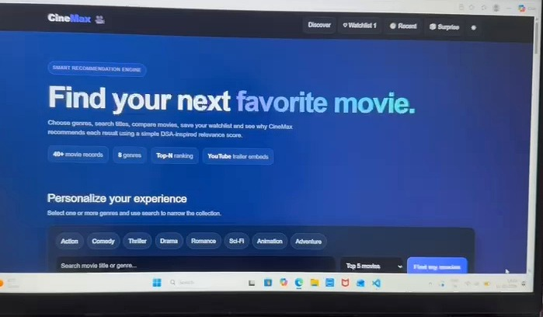
Figure 1. CineMax landing page and discovery entry point.

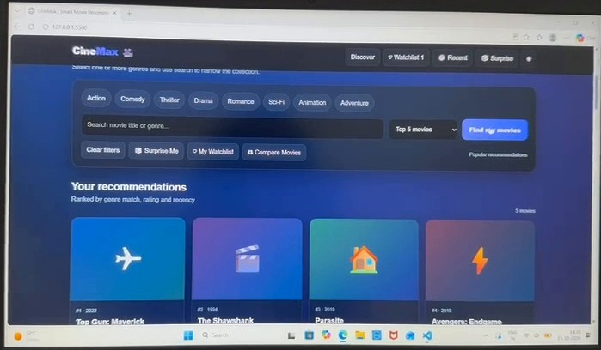
Figure 2. Genre filters, search field, result limit, and ranked recommendation cards.

8.CONCLUSION & FUTURE SCOPE
CineMax demonstrates a practical movie discovery workflow. It accepts user preferences, searches and filters movie records, computes a transparent relevance score from genre matching, rating, and recency, and sorts the results to show a limited list of recommendations. The watchlist, recent items, comparison, Surprise Me, and trailer features make the interface more useful for exploring movies. The project illustrates how data structures, searching, string matching, scoring, and sorting can work together in a real application. Because no formal benchmark or user study was supplied, the project does not claim a measured accuracy percentage.

Future scope:
• Expand and validate the movie dataset and handle missing or inconsistent metadata.
• Add more efficient indexing or hash-based lookup for larger catalogues.
• Improve ranking with user ratings, watch history, and feedback.
• Add collaborative filtering or hybrid recommendation methods.
• Add login and persistent, user-specific watchlists.
• Evaluate quality using a defined test set and metrics such as precision@k, recall@k, and response time.
• Improve accessibility, mobile responsiveness, and deployment.

9.REFERENCES

1. Netflix, “How Netflix’s Recommendations System Works,” https://help.netflix.com/en/node/100639 (accessed 11 Oct. 2026).
2. IMDb, “IMDb Help Center,” https://help.imdb.com/ (accessed 11 Oct. 2026).
3. The Movie Database (TMDB), “API Documentation,” https://developer.themoviedb.org/docs (accessed 11 Oct. 2026).
4. Letterboxd, “About Letterboxd,” https://letterboxd.com/about/ (accessed 11 Oct. 2026).
5. YouTube, “YouTube Embedded Players and Player Parameters,” https://developers.google.com/youtube/iframe_api_reference (accessed 11 Oct. 2026).
6. Amazon Science, “Personalized Recommendations,” https://www.amazon.science/ (accessed 11 Oct. 2026).
7. Google Books, https://books.google.com/ (accessed 11 Oct. 2026).
8. F. Ricci, L. Rokach, and B. Shapira, eds., Recommender Systems Handbook, 3rd ed., Springer, 2022.
9. MDN Web Docs, “Array.prototype.sort(),” https://developer.mozilla.org/en-US/docs/Web/JavaScript/Reference/Global_Objects/Array/sort (accessed 11 Oct. 2026).
10. MDN Web Docs, “String.prototype.includes(),” https://developer.mozilla.org/en-US/docs/Web/JavaScript/Reference/Global_Objects/String/includes (accessed 11 Oct. 2026).

